**Lab Practical #12:**

Identify type of network in your institute. Study a design of network in your institute.

**Practical Assignment #12:**

1. **Identify type of network in your institute. Draw a design of network in your institute (Any Lab/Floor/Building).**

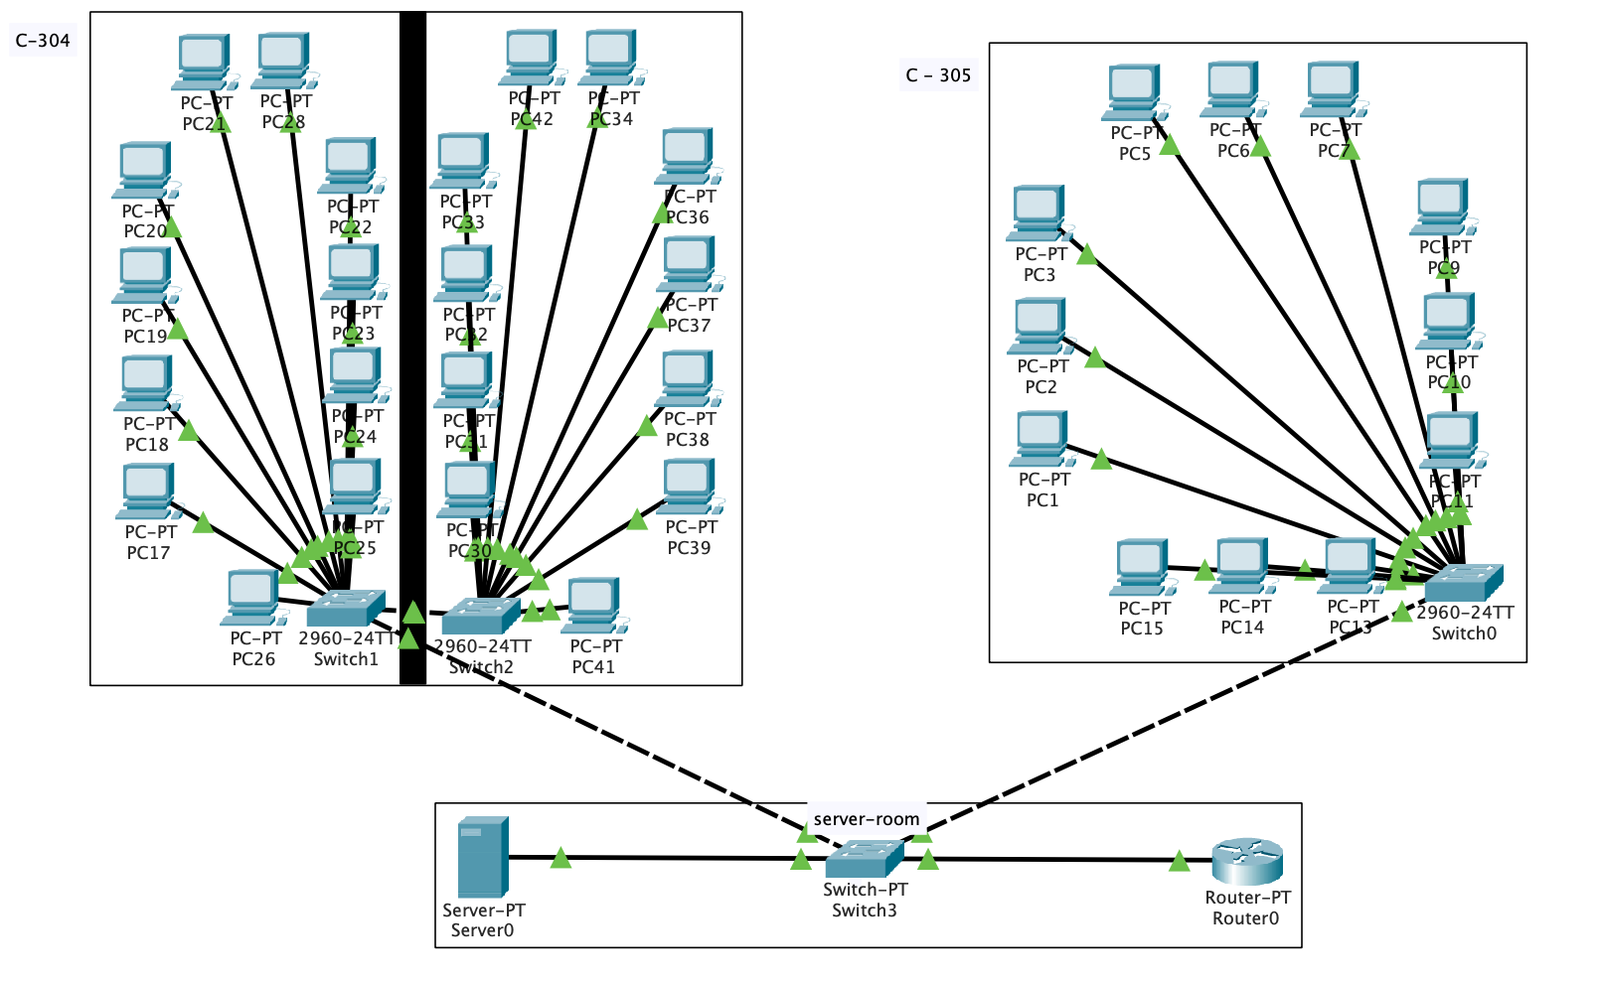

1. **Mention how many network devices used and its details.**

* There are 4 types of network devices used.
* In Lab C-304, the lab is divided into two partitions.
* In Lab C-305, The computers are arranged in sequence.
* star topology is used for connection between computers and switch.
* All the computers of lab are connected with common switch.
* All two switch from both lab is connected to the common switch.
* Again, use star connection in switch where two switch, router and server are connected
* The switch is connected to server and router.
* The server is joining with switch in the same network.
* In the server we use DHCP protocol for provide IP address in range 192.168.1.0 to all the computer in network.
* The router is used to connect two different network in case we use.